Aaron Shipley

CS 360

Assignment 4-4 : UI Design

Southern New Hampshire University

Jerome DiMarzio

9/21/2022

When looking for a reference page to recreate, I navigated multiple apps. When researching, the app that I chose to recreate a page from is the Amazon mobile app. The page in particular is the “My Lists” page. The page was selected due to my extensive experiences with it. I have long wished the page resembled a more fluid approach to its design, much like the rest of the app contains. The structure of the page does not provide a feel of a mobile app, but that of a basic web page on a PC. Below are figures of the original design of the app and a remodeled version of the page.

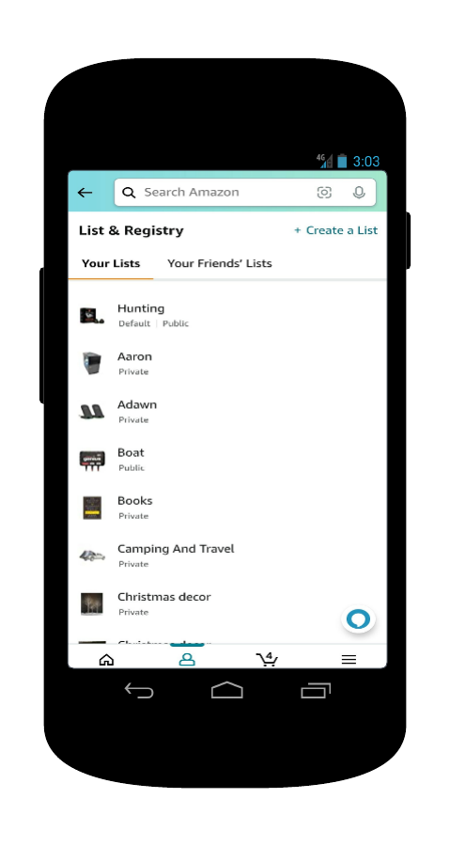 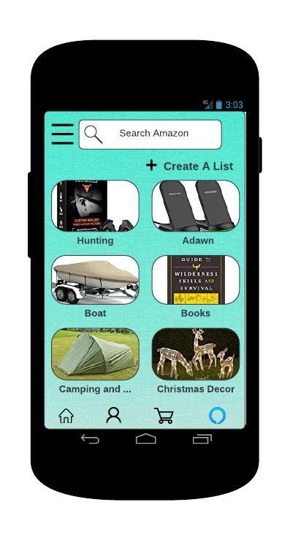

When reviewing the two versions of the page, the essential goals of the page remain the same for the user. The pages allow a user to navigate through their created lists. The user can also create a list. The user will use the navigation bar to access other pages on the app as well. The page provides a menu of options for the user to select from.

The first difference one may see in the pages is the color scheme of the background. The original screen has an experience of a list of items, similar to a spreadsheet. The Amazon “seafoam” color is added to the background to give the app a more distinct appearance. This scheme can be used to reinforce Amazon’s unique look and color for easy recognition. Another difference in the pages is the navigation bar. The original navigation bar had icons to access the user’s account, the home screen, the shopping cart, and the hamburger icon for the menu. The remodeled screen eliminates the menu from the navigation bar. The menu is taken to the top left of the screen next to the search bar. This fits more general mobile app conformity rules. With the elimination of the menu icon, the remodeled version incorporates the Alexa icon to access the amazon virtual assistant. This was originally located on each screen above the navigation bar, nearly blending into the screen, and can be under-utilized.

The original screen listed the lists in a vertical-list view, utilizing a small icon of the last item added to the list. The remodeled version utilizes card UI components, displaying the last item added to the respective list and the list’s name below the card. The card components are arranged into two columns, with rows being determined by the number of lists the user has. The reason for using card components for the lists is UI appeal to the user. By having visual cards instead of a vertical text list, the user can gain a sense of using a mobile app instead of a desktop browser. This key in the user’s experience and can effect the amount the user accesses the app. On the original screen, a back button was directly left of the search bar. This component was eliminated due to the Android quality app core guidelines. Since Android provides a back button, the app should not utilize an independent back button. With its elimination, this made room for the menu to go in its place and the Alexa icon to be placed on the navigation bar.

The overall remodel of the app fits into the Android development guidelines in multiple facets. The page will be compatible in portrait or landscape modes. The use of Alexa will start, but when complete the app will resume in the foreground. All touch buttons are 480dp, allowing for adequate space for the user to select their desired option. The text is uniformly spaced throughout the page and contains adequate space from other components on the screen. The elimination of the back arrow within the app fits guidelines as discussed previously. This remodel was intended for improvement of life and visual appeal per the Android guidelines.

References

Google Developers. (2022). *Developers Guide*. Android Developers. Retrieved September 21, 2022, from https://developer.android.com/docs/quality-guidelines/large-screen-app-quality

Riva, M. D. L. (2022, March 29). *32 UI elements designers need to know*. CareerFoundry. Retrieved September 21, 2022, from https://careerfoundry.com/en/blog/ui-design/ui-element-glossary/